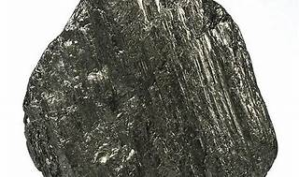

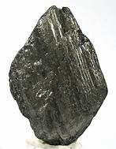

Explore

**Graphite** is a **pure form of carbon** with a crystalline structure that allows it to store **lithium ions**. [In the context of technology, it plays a crucial role in **battery anodes**, including those used in electric vehicles (EVs)](https://chargedevs.com/features/a-closer-look-at-graphite-its-forms-functions-and-future-in-ev-batteries/) [1](https://chargedevs.com/features/a-closer-look-at-graphite-its-forms-functions-and-future-in-ev-batteries/).

Here are **five reference links** where you can learn more about graphite and its applications:

1. [**A closer look at graphite—its forms, functions, and future in EV batteries**](https://chargedevs.com/features/a-closer-look-at-graphite-its-forms-functions-and-future-in-ev-batteries/): This article provides insights into the different forms of graphite, its role in EV batteries, and industry trends.
2. [**Cambridge Dictionary: Graphite**](https://dictionary.cambridge.org/dictionary/english/graphite): A concise definition of graphite as a soft, dark grey carbon used in pencils, machinery lubrication, and nuclear reactors [2](https://dictionary.cambridge.org/dictionary/english/graphite).
3. [**Merriam-Webster: Graphite**](https://www.merriam-webster.com/dictionary/graphite): A detailed definition of graphite, including its use in lead pencils, electrolytic anodes, and as a moderator in nuclear reactors [3](https://www.merriam-webster.com/dictionary/graphite).
4. [**Oxford Learner’s Dictionaries: Graphite**](https://www.oxfordlearnersdictionaries.com/definition/english/graphite): Learn about graphite as a soft black mineral used for pencils, machinery lubrication, and nuclear reactors [4](https://www.oxfordlearnersdictionaries.com/definition/english/graphite).
5. **Graphite on Wikipedia**: Explore the comprehensive Wikipedia page on graphite, covering its properties, applications, and historical context.

Feel free to explore these resources to deepen your understanding of this fascinating material! 🚀🔋